**CREATING NEW JUPYTER NOTEBOOK:**

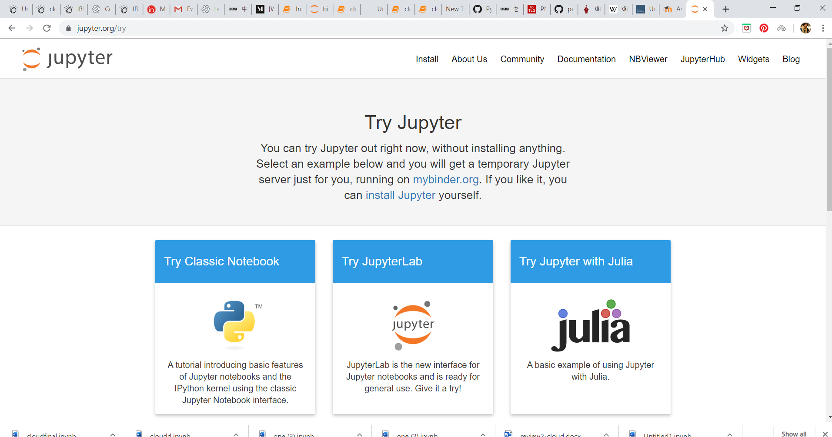

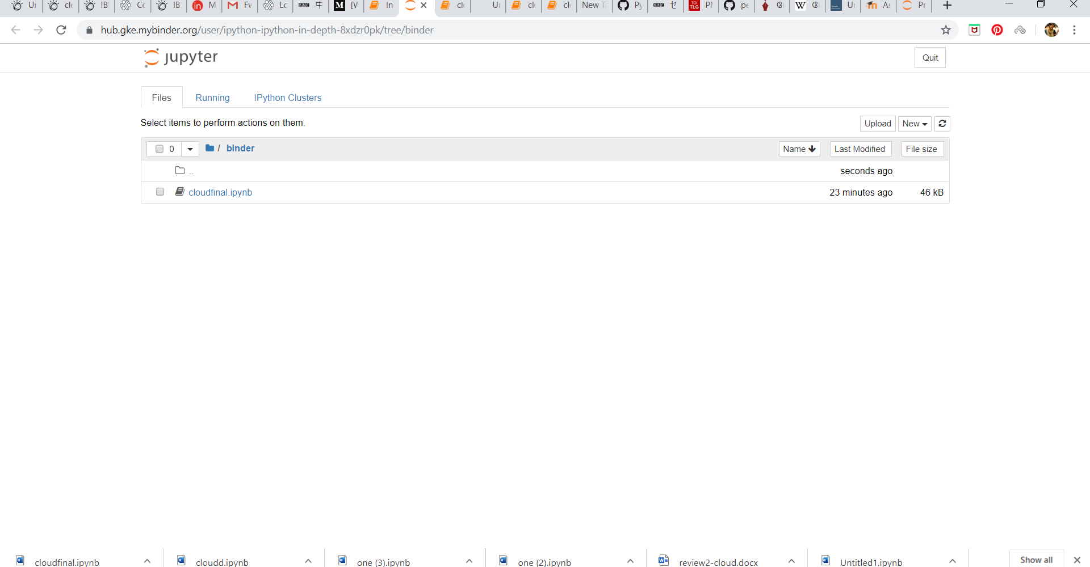

**IMPLEMENTATION OF TEXTSUMMARIZATION:**

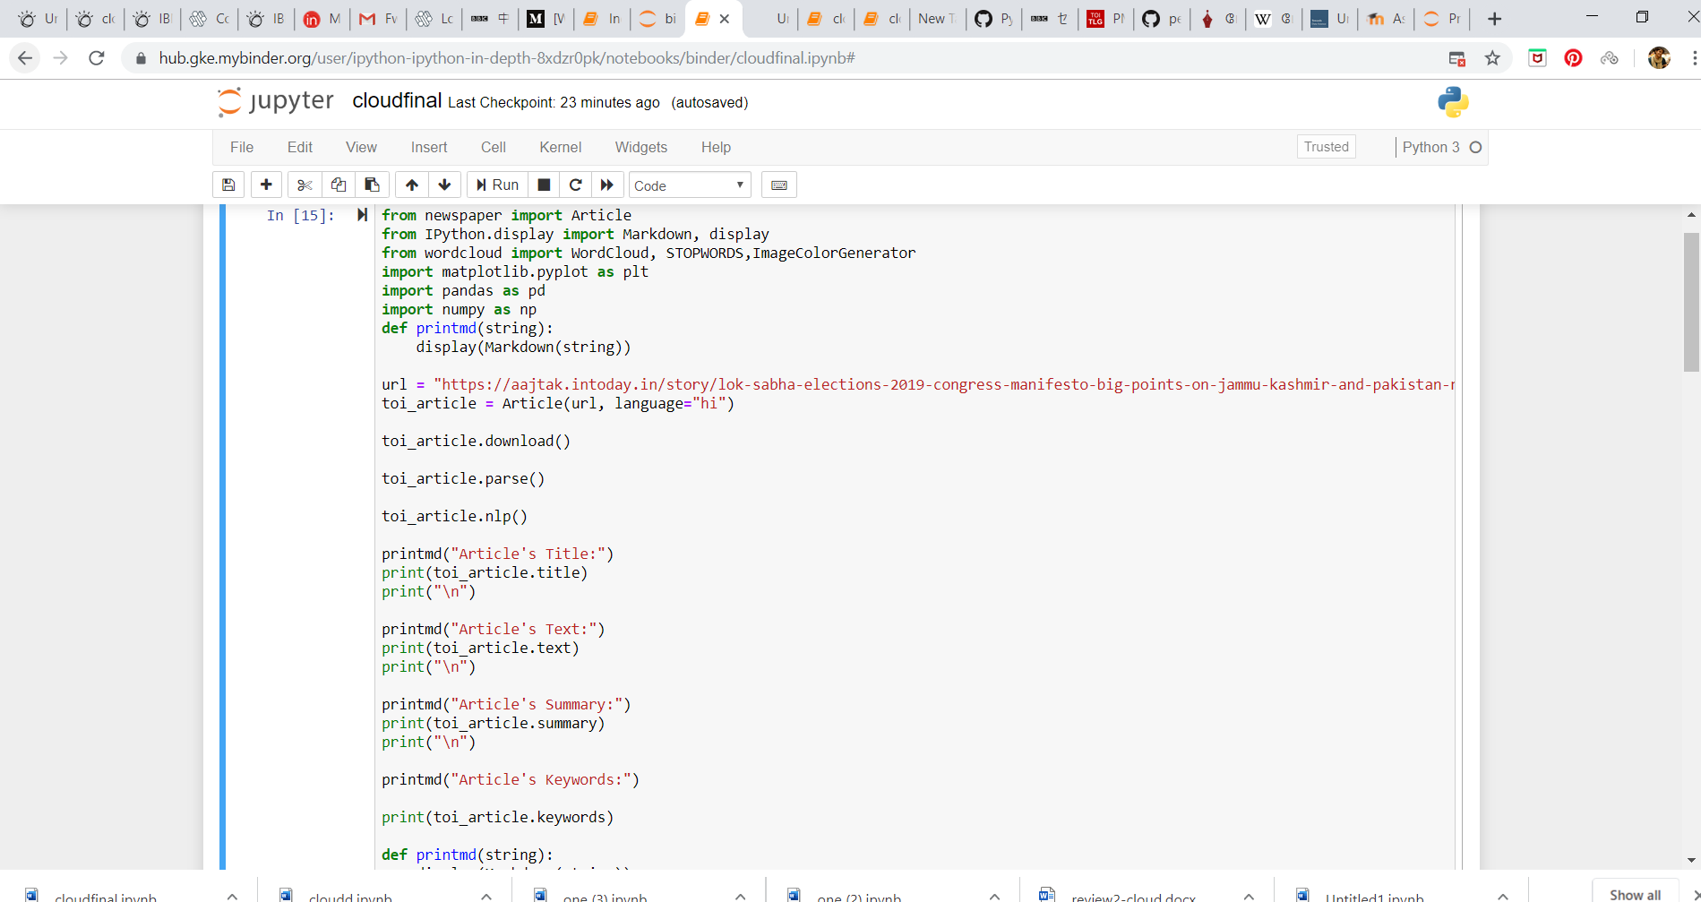

**OUTPUT:**

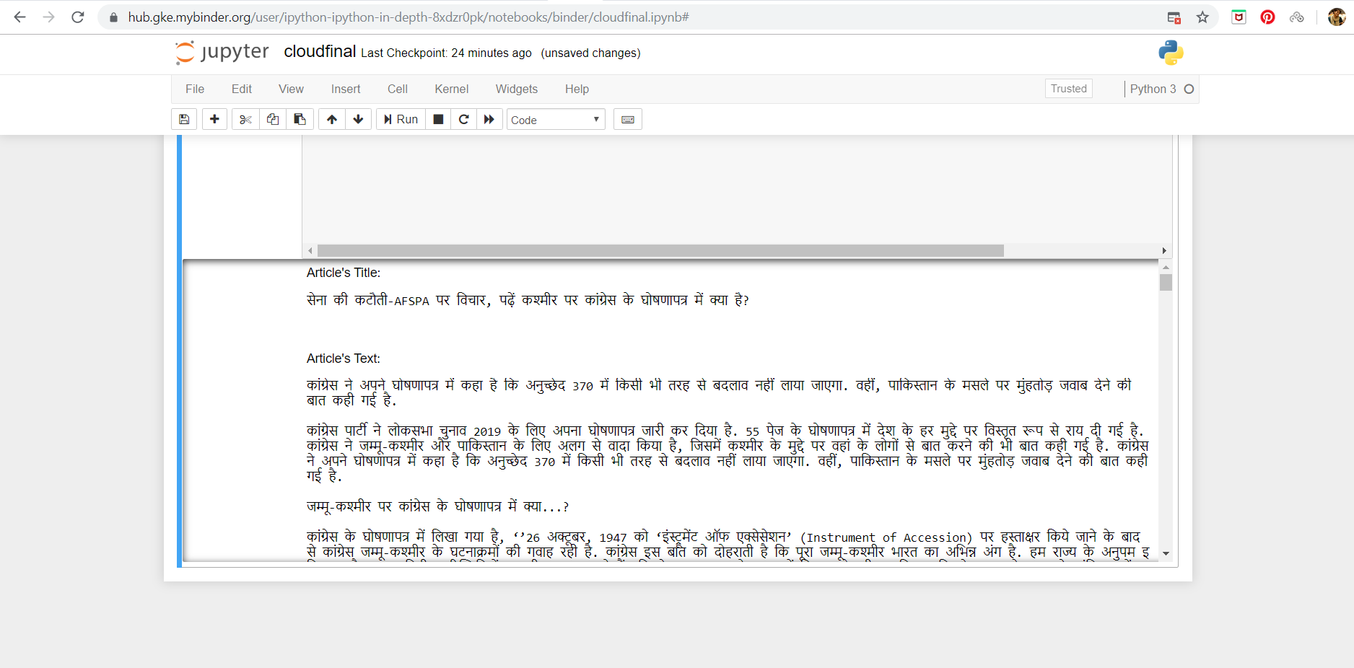

**CREATING IBM WATSON STUDIO ACCOUNT:**

**URL:** <https://eu-gb.dataplatform.cloud.ibm.com/>

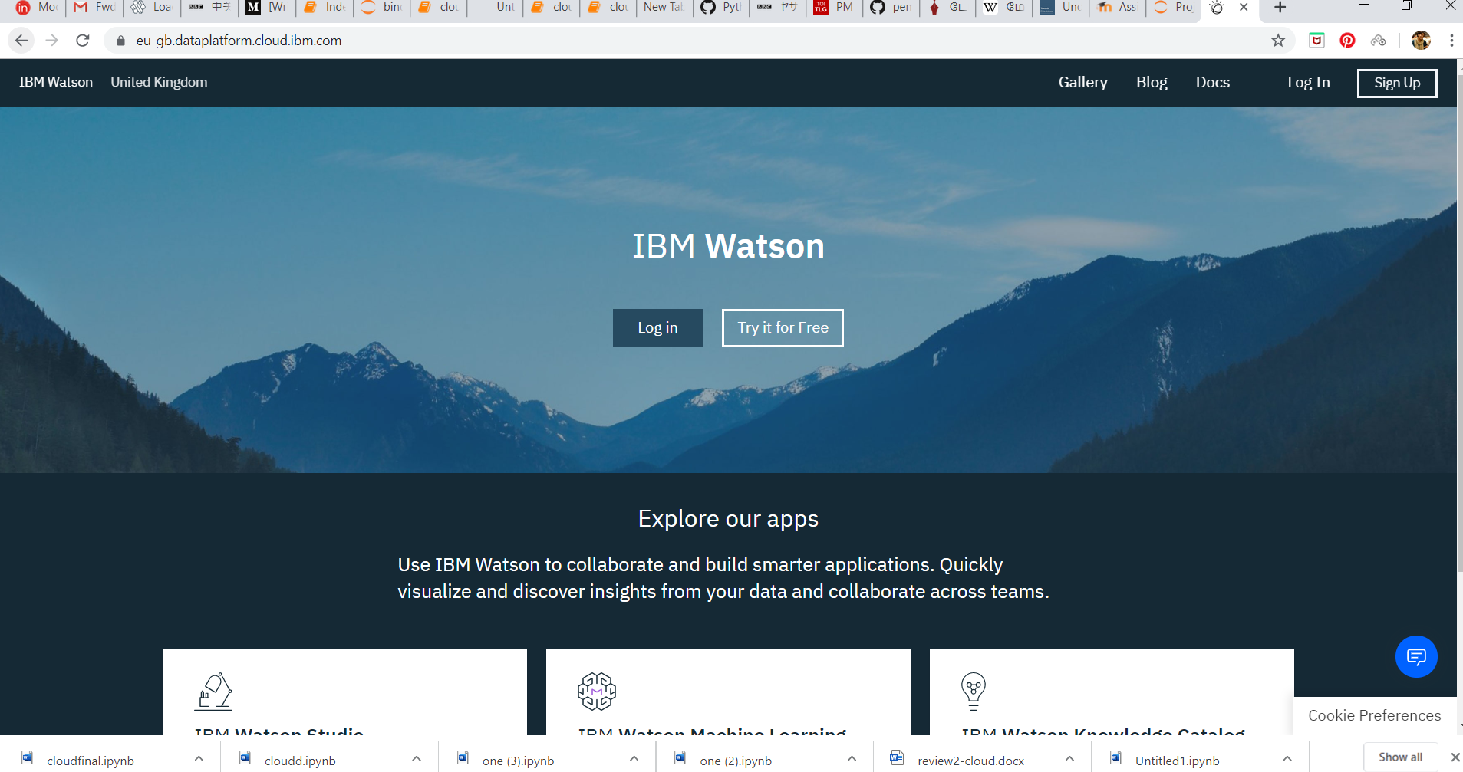

**CREATING A PROJECT:**

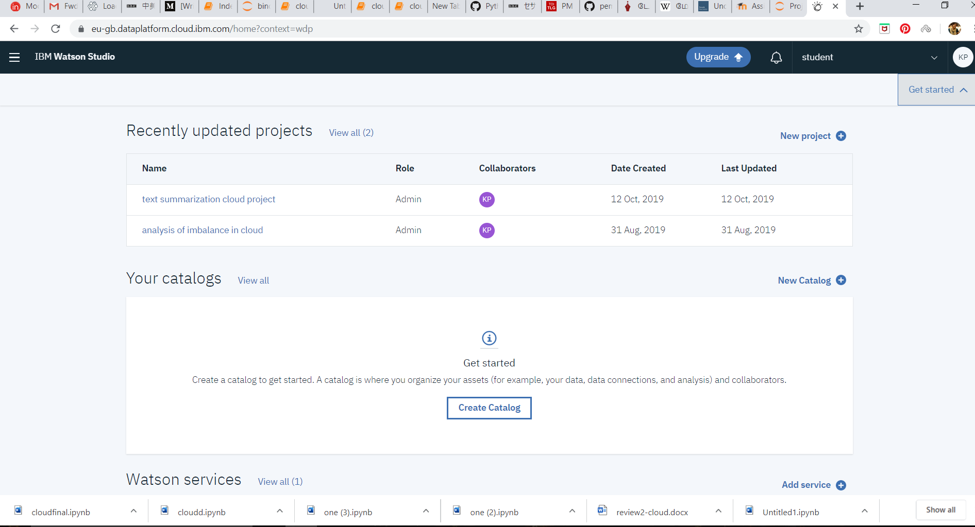

**ADDING ASSET TYPE AS NOTEBOOK:**

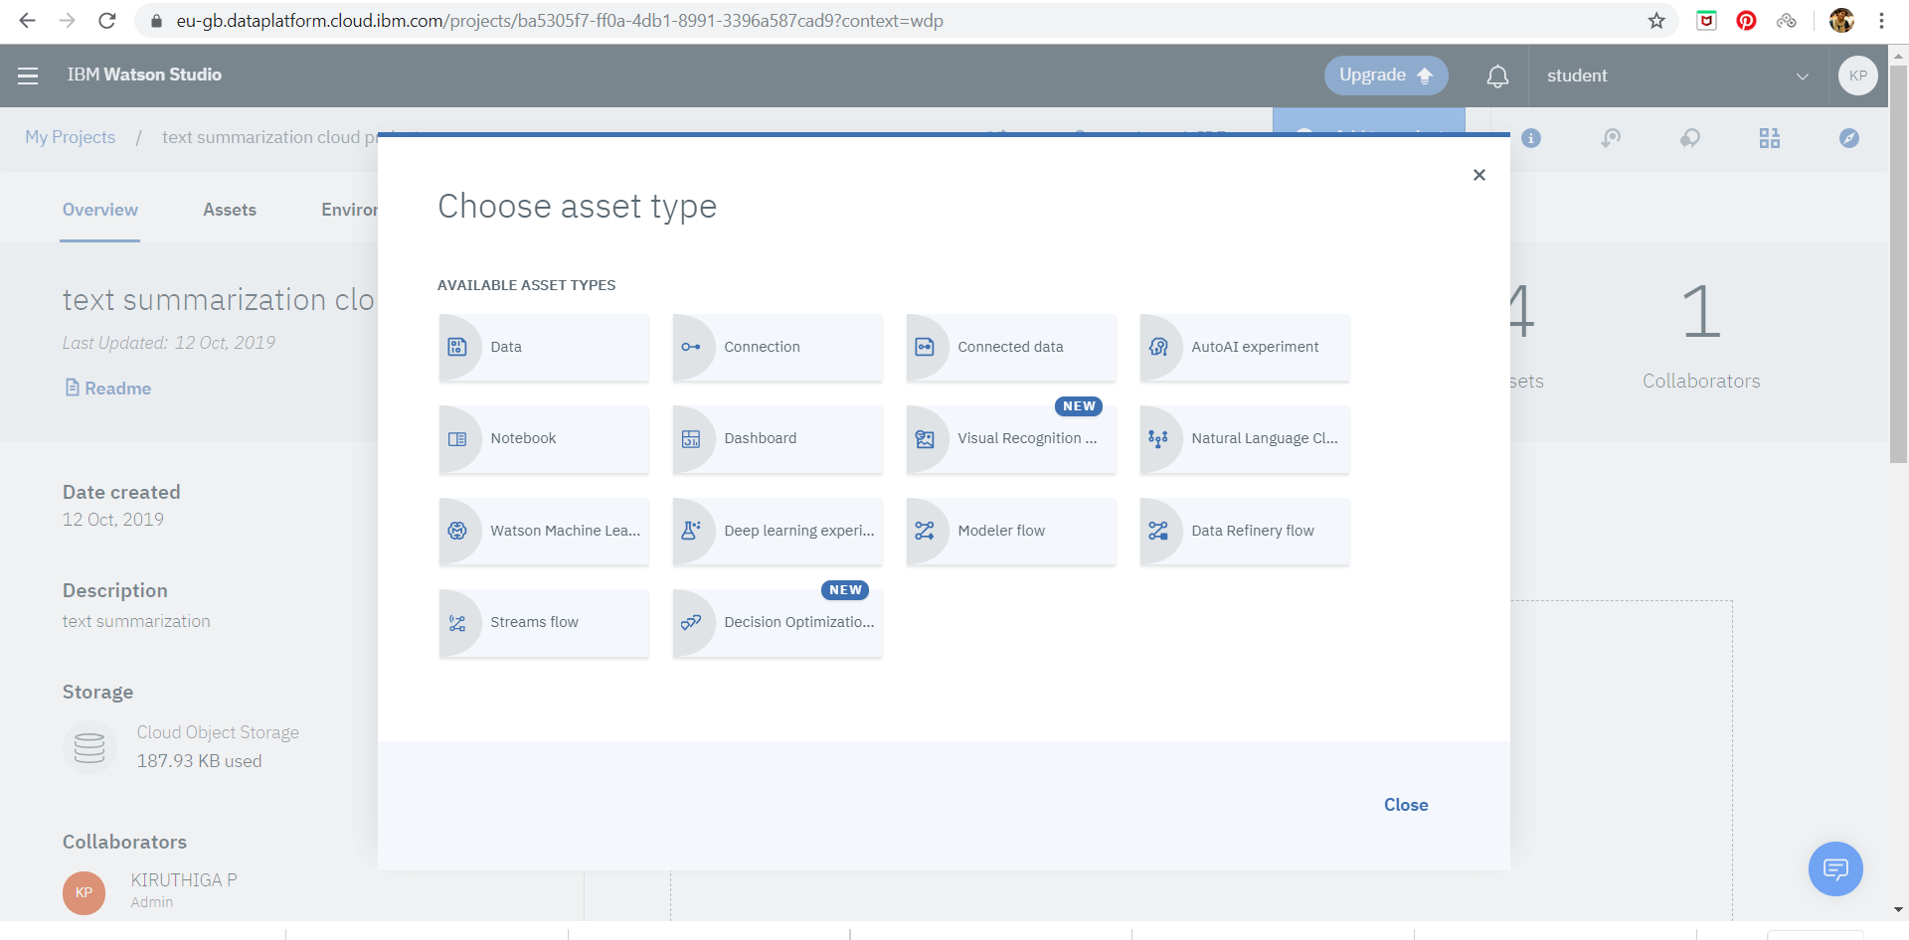

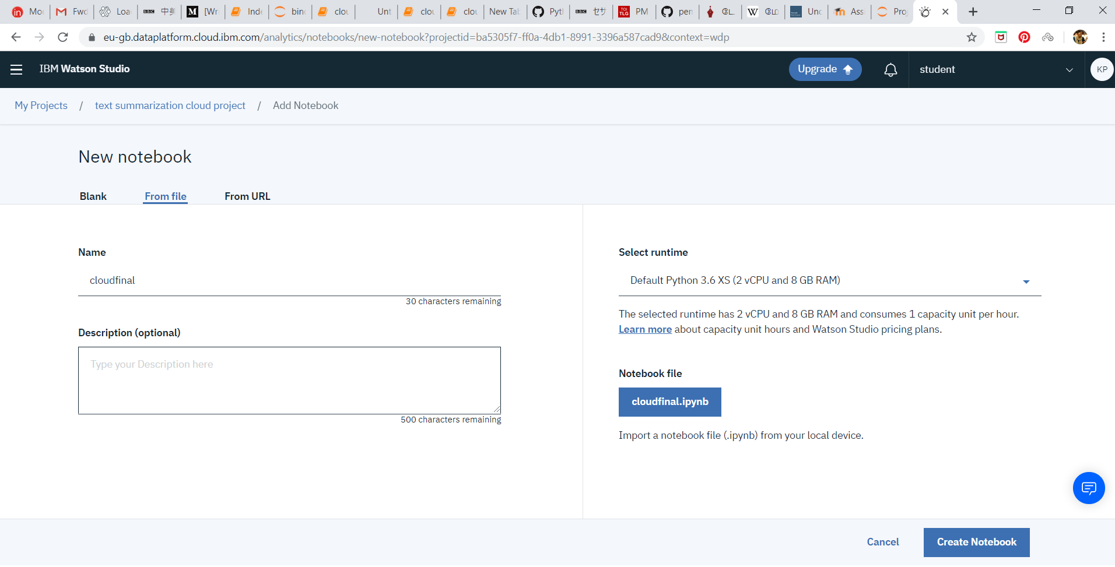

**NOTEBOOK ADDED AS AN ASSET:**

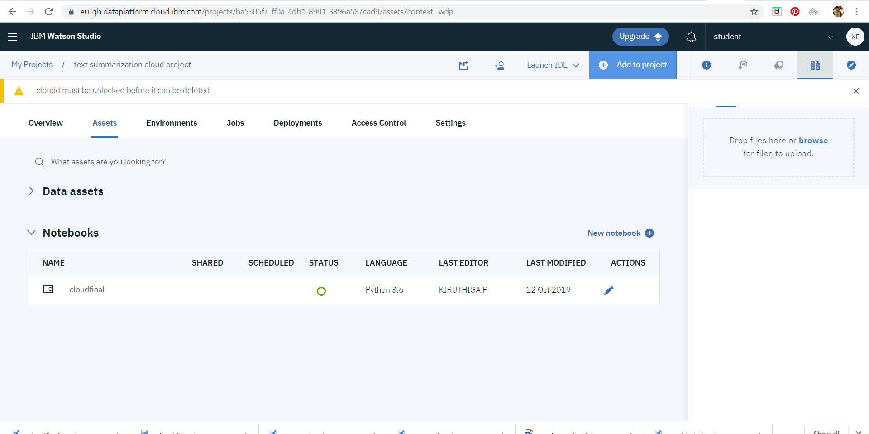

**IMPLEMENTATION OF JUPYTER NOTEBOOK FILE:**

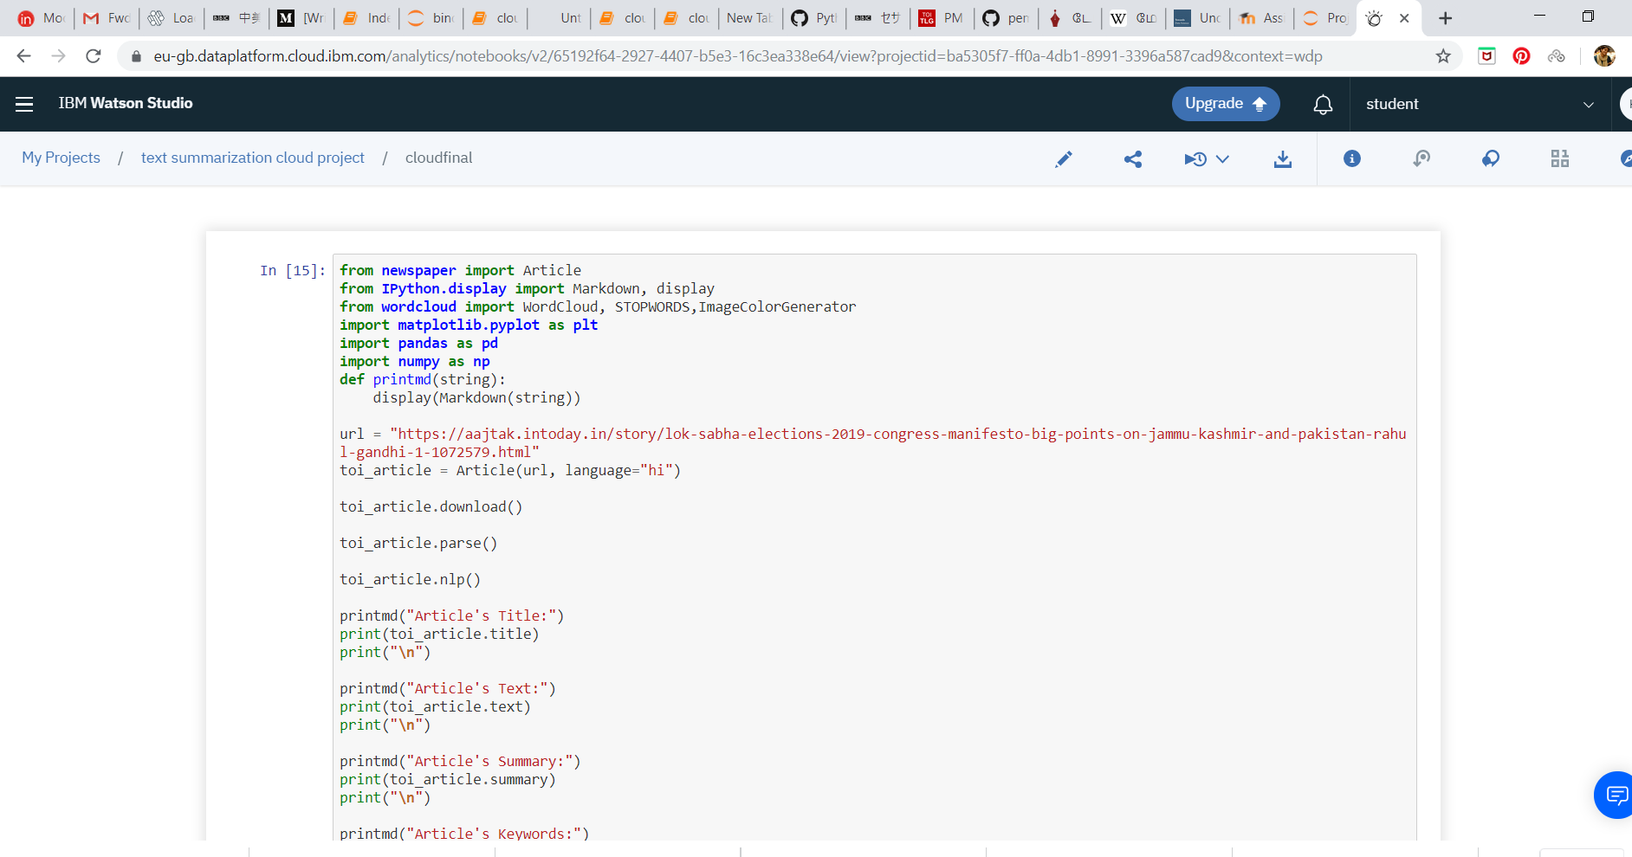

**OUTPUT:**

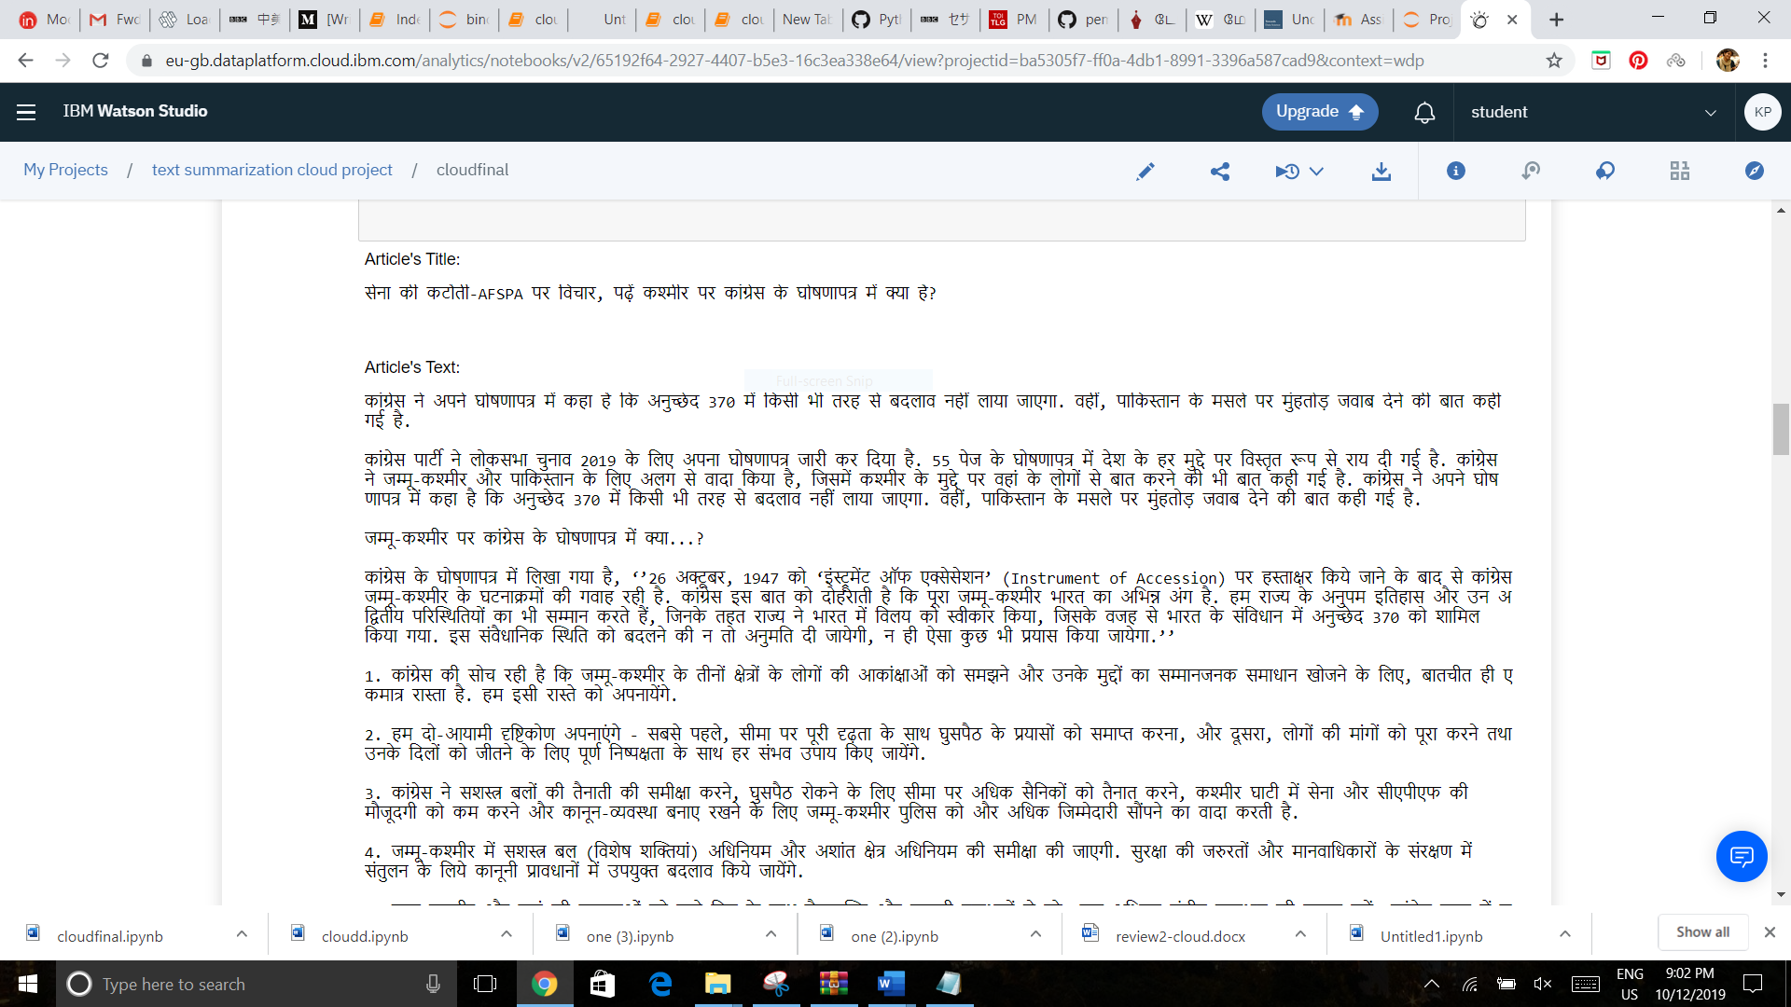

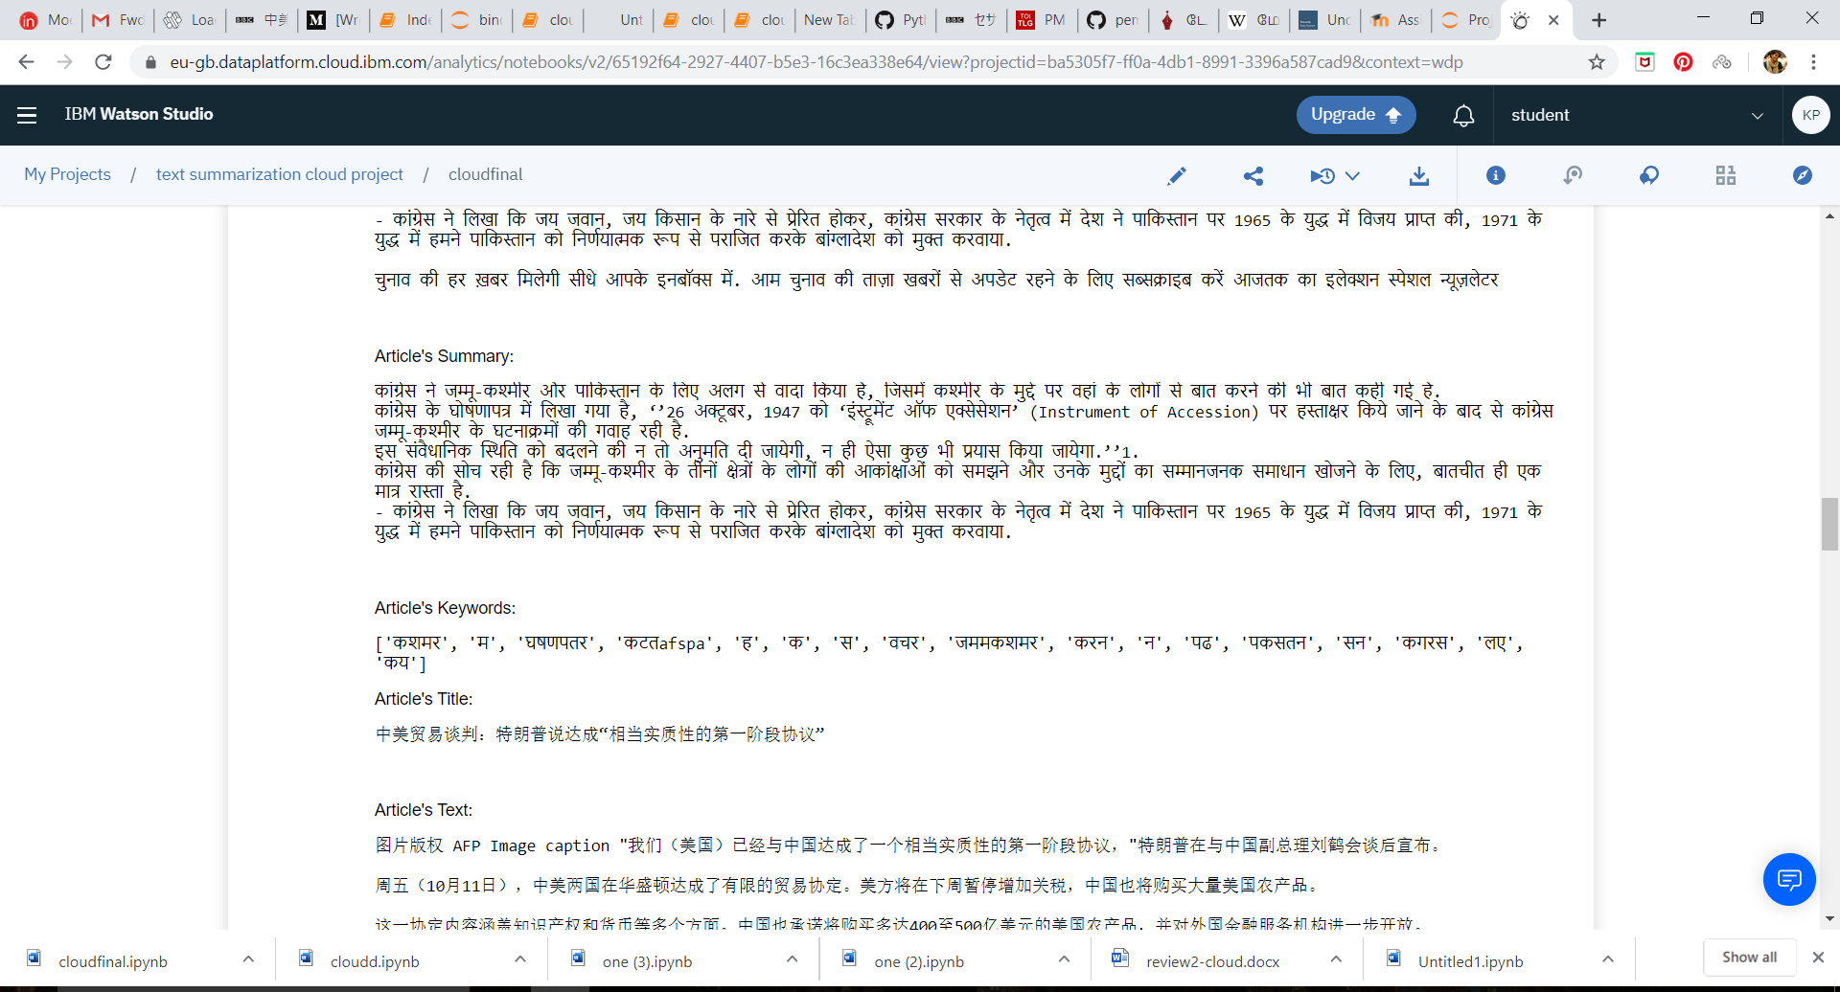

**STORAGE USED:**

**CLOUD OBJECT STORAGE:**

